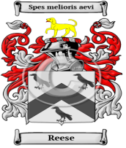©THE REECE/REESE FAMILY MEMORIAL PARK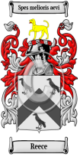

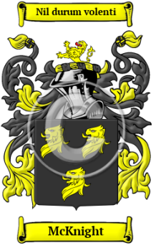
THE HISTORY/LEGACY/EDUCATION/HERITAGE AND LOVE OF THE REECE/REESE/McKNIGHT FAMILY OF AGES!
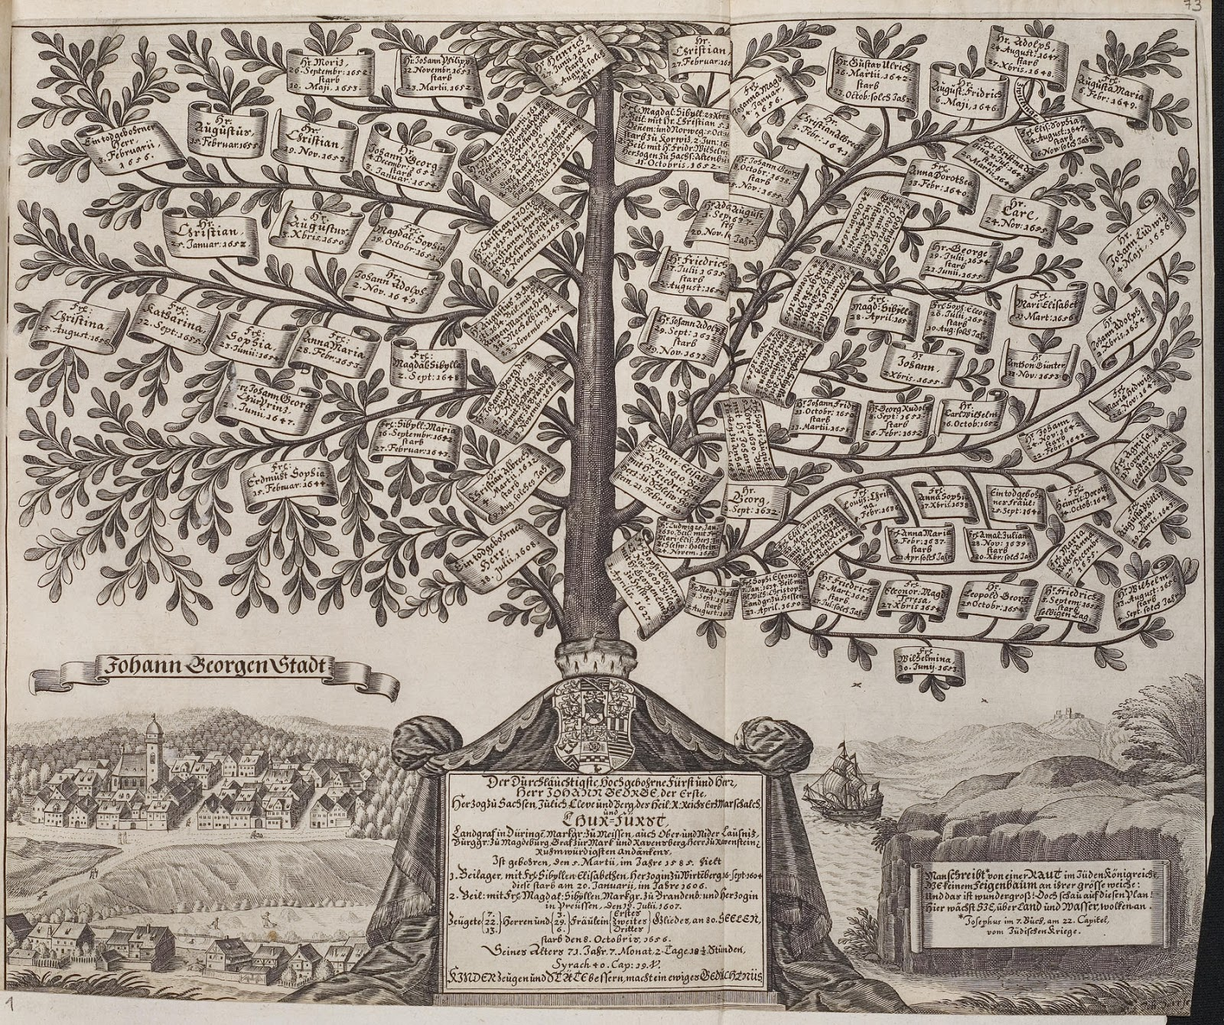

STARTED: BY Terry “the Warrior” Reece
THESE STORIES HOLD LEGENDARY TRUE/TRUTHS=AS TOLD BY “REECE/REESE/MCKNIGHT” AND EXTENDED FAMILY MEMBERSAND THESE MATERIALS AND CONTENT AR THE PROPERTIES OF THE FAMILIES WHO VOLUNTARILY POST/WRITE AND SHARE HISTORY HERITAGES, LEGACIES AND TRUE RECORDS OF THE AGES OF THESE CONNECTED FAMILIES…

©COPYRIGHT October 26, 2021; BY THE REECE/REESE/McKNIGHT, GROUPS OF EXTENDED FAMILIES ©THE REECE/REECE FAMILY MEMORIAL PARK ,: is A PRODUCT BRAND OF ©REECENETRICS™ BY ®REECE ENTERPRISES/TIME TRAVEL NETWORK, INC./FAMILY MEDIA COMPANY/TDM COMICS INTERNATIONAL, and Jointly owned by All Participating REECE/REESE/McKNIGHT EXTENDEDGROUPS OF FAMILY HERITAGE/LEGACY/HISTORICAL MEMBERS: #TX7-391-838, PREVIOUS REGISTRATION AND YEAR: Txu000523784 1992.

Reece History, Family Crest & Coats of Arms
The origins of the Welsh name Reece go back to those ancient Celts known as the Britons that once occupied the hills and Moors of Wales. This old Welsh surname is from the Welsh personal name Rhys, which also took the forms Rice and Rees. This name was originally derived from the Old Welsh forename Ris, which means ardour.

Early Origins of the Reece family
The surname Reece was first found in Carmarthenshire (Welsh: Sir Gaerfyrddin), located in Southwest Wales, one of thirteen historic counties and presently one of the principal area in Wales. Sir Elidir Dhu who flourished temp. Richard I., was the direct descendant of the family of Rees of Killymaenllwyd, county Carmarthen. ^{[1]}
"In 1115, Grufydd ab Rhys, Prince of South Wales, took sanctuary in the church of Aberdaron, from the treachery of Grufydd ab Cynan, sovereign of North Wales, who intended to deliver him into the hands of the English monarch, Henry I. The young prince escaped with his partisans by night, and set forward on his journey to the deep forest of Strath Towy, in South Wales, where, having collected the adherents of his family, he commenced hostilities against the Norman and Flemish settlers. " ^{[2]}

Early History of the Reece family
This web page shows only a small excerpt of our Reece research. Another 124 words (9 lines of text) covering the years 1615, 1541, 1624 and 1616 are included under the topic Early Reece History in all our PDF Extended History products and printed products wherever possible.

Reece Spelling Variations
Although there are comparatively few Welsh surnames, they have a great many spelling variations. Variations of Welsh names began almost immediately after their acceptance within Welsh society. In the Middle Ages, it was up to priests and the few other people that recorded names in official documents to decide how to spell the names that they heard. Variations that occurred because of improper recording increased dramatically as the names were later transliterated into English. The Brythonic Celtic language of Wales, known by natives as Cymraeg, featured many highly inflected sounds that could not be properly captured by the English language. Spelling variations were, however, also carried out according to an individual's design: a branch loyalty within the family, a religious adherence, or even patriotic affiliations were all indicated by the particular variation of one's name. The spelling variations of the name Reece have included Rees, Reece, Rhys, Ap Rhys and others.

Early Notables of the Reece family (pre 1700)
Prominent amongst the family during the late Middle Ages was Edmund Prys (c. 1541-1624), Welsh translator of the psalms into Welsh verse, son of Sion (John) ap Rhys of Tyddyn Du in the parish of Maen Twrog, Merionethshire. Prys was a skilful composer in the strict Welsh metres, and took an active part in the bardic life of his time. ^{[3]} Lewys Dwnn or more properly Lewys ap Rhys ap Owain (d. 1616?), was "Deputy-Herald for Wales, derived his accepted surname from...
Another 81 words (6 lines of text) are included under the topic Early Reece Notables in all our PDF Extended History products and printed products wherever possible.

Reece Ranking
In the United States, the name Reece is the 1,278th most popular surname with an estimated 24,870 people with that name. ^{[4]}

Reece migration to the United States +

The Welsh began to emigrate to North America in the late 1800s and early 1900s in search of land, work, and freedom. Those that arrived helped shape the industry, commerce, and the cultural heritage of both Canada and the United States. The records regarding immigration and passenger show a number of people bearing the name Reece:

Reece Settlers in United States in the 17th Century
- Gennet Reece, who arrived in America in 1654-1679 ^{[5]}
- Roger Reece, who landed in America in 1654-1679 ^{[5]}
- Ann Reece, who landed in New England in 1662 ^{[5]}
- Henry Reece, who settled in Nevis in 1663 along with Jane
- Richard Reece, who settled in New England in 1668
- ... (More are available in all our PDF Extended History products and printed products wherever possible.)

Reece Settlers in United States in the 18th Century
- Matthew Reece, aged 17, who landed in Pennsylvania in 1738 ^{[5]}
- Jacob Reece, aged 49, who landed in Pennsylvania in 1738 ^{[5]}

Reece Settlers in United States in the 19th Century
- John Reece, who arrived in Allegany (Allegheny) County, Pennsylvania in 1828 ^{[5]}
- William Reece, who arrived in Alabama in 1858 ^{[5]}
- Barbara, Jacob, Mathew, Thomas and William Reece all, who arrived in Philadelphia between 1840 and 1870

Reece migration to Canada +

Some of the first settlers of this family name were:

Reece Settlers in Canada in the 18th Century
- Mr. Alexander Reece U.E. who settled in Cumberland Bay, Queens County, New Brunswick c. 1784 ^{[6]}

Reece migration to Australia +

Emigration to Australia followed the First Fleets of convicts, tradespeople and early settlers. Early immigrants include:

Reece Settlers in Australia in the 19th Century
- Mr. Richard Reece, English convict who was convicted in Shropshire, England for 7 years, transported aboard the "Dromedary" on 11th September 1819, arriving in Tasmania ( Van Diemen's Land) ^{[7]}
- Charles Reece, Jr., English convict from Worcester, who was transported aboard the "Asia" on September 3rd, 1820, settling in New South Wales, Australia ^{[8]}
- Mr. William Reece, English convict who was convicted in Cambridge, Cambridgeshire, England for life, transported aboard the "Aurora" on 3rd November 1833, arriving in New South Wales, Australia ^{[9]}
- Eleanor Reece, aged 24, who arrived in Adelaide, Australia aboard the ship "Marion" in 1849 ^{[10]}
- Mr. George Reece, (b. 1823), aged 25, English convict who was convicted in Bridgewater, Somerset, England for 7 years for assault, transported aboard the "Bangalore" on 1st January 1850, arriving in Moreton Bay, Queensland, Australia, he died in 1859 ^{[11]}

Reece migration to New Zealand +

Emigration to New Zealand followed in the footsteps of the European explorers, such as Captain Cook (1769-70): first came sealers, whalers, missionaries, and traders. By 1838, the British New Zealand Company had begun buying land from the Maori tribes, and selling it to settlers, and, after the Treaty of Waitangi in 1840, many British families set out on the arduous six month journey from Britain to Aotearoa to start a new life. Early immigrants include:

Reece Settlers in New Zealand in the 19th Century
- Mr. William Reece, (b. 1802), aged 45, Welsh , born in Glamorgan, Wales settler arriving as 1st detachment of Royal New Zealand Fencible Corps travelling from Tilbury, Essex aboard the ship "Ramillies" arriving in Auckland, New Zealand on 6th August 1847 ^{[12]}
- Mrs. Mary Ann Reece née Fitzgerald, (b. 1816), aged 31, Irish , born in Ireland settler travelling from Tilbury, Essex aboard the ship "Ramillies" arriving in Auckland, New Zealand on 6th August 1847 ^{[12]}
- Mr. John Reece, (b. 1832), aged 15, Welsh , born in Glamorgan, Wales settler travelling from Tilbury, Essex aboard the ship "Ramillies" arriving in Auckland, New Zealand on 6th August 1847 ^{[12]}
- Miss Elizabeth Reece, (b. 1838), aged 9, English , born in Devon settler travelling from Tilbury, Essex aboard the ship "Ramillies" arriving in Auckland, New Zealand on 6th August 1847 ^{[12]}
- Miss Delinah Reece, (b. 1841), aged 6, Welsh , born in Glamorgan, Wales settler travelling from Tilbury, Essex aboard the ship "Ramillies" arriving in Auckland, New Zealand on 6th August 1847 ^{[12]}
- ... (More are available in all our PDF Extended History products and printed products wherever possible.)

Contemporary Notables of the name Reece (post 1700) +

- Jane B. Reece (b. 1944), American scientist and textbook author
- Shakera Kiella Valena Reece (b. 1988), Barbadian sprinter at the 2011 Pan American Games
- Florence Reece (1900-1986), American social activist, poet, and folksong writer, known for the song, "Which Side Are You On?"
- Beasley Young Reece Jr. (b. 1954), American NFL football defensive back who played from 1976 to 1984
- Gabrielle Allyse Reece (b. 1970), American professional volleyball player, sports announcer, fashion model and actress
- Brazilla Carroll Reece (1889-1961), American politician, Member of the U.S. House of Representatives from Tennessee (1921-1931)
- Marcel Antoine Wayne Reece (b. 1985), American NFL football fullback for the Oakland Raiders
- Christopher "Chris" Reece (b. 1959), American musician
- Jimmy Reece (1929-1958), American racecar driver
- Alicia Reece, American Democratic Party politician, Delegate to Democratic National Convention from Ohio, 2000, 2004 ; Candidate in primary for Mayor of Cincinnati, Ohio, 2005 ^{[13]}
- ... (Another 24 notables are available in all our PDF Extended History products and printed products wherever possible.)

Historic Events for the Reece family +

Related Stories +

The Reece Motto +

The motto was originally a war cry or slogan. Mottoes first began to be shown with arms in the 14th and 15th centuries, but were not in general use until the 17th century. Thus the oldest coats of arms generally do not include a motto. Mottoes seldom form part of the grant of arms: Under most heraldic authorities, a motto is an optional component of the coat of arms, and can be added to or changed at will; many families have chosen not to display a motto.
Motto: Spes melioris aevi
Motto Translation: The hope of a better age.

Suggested Readings for the name Reece +

- The Reeces of Worcester, Mass. by Louise Elise Jackson Wilder.

McKnight History, Family Crest & Coats of Arms
- Origins Available:
- Scotland
- Ireland

Early Origins of the McKnight family
The surname McKnight was first found in Kirkcudbright, where they held a family seat from early times and their first records appeared on the early census rolls taken by the early Kings of Britain to determine the rate of taxation of their subjects.

Early History of the McKnight family
This web page shows only a small excerpt of our McKnight research. Another 60 words (4 lines of text) are included under the topic Early McKnight History in all our PDF Extended History products and printed products wherever possible.

McKnight Spelling Variations
Spelling variations of this family name include: MacKnight, MacKnyght, MacNaught, MacNaight, MacKnaught, MacKnaight, MacNight and many more.

Early Notables of the McKnight family (pre 1700)
More information is included under the topic Early McKnight Notables in all our PDF Extended History products and printed products wherever possible.

McKnight Ranking
In the United States, the name McKnight is the 754th most popular surname with an estimated 39,792 people with that name. ^{[1]}

Migration of the McKnight family to Ireland
Some of the McKnight family moved to Ireland, but this topic is not covered in this excerpt.
Another 68 words (5 lines of text) about their life in Ireland is included in all our PDF Extended History products and printed products wherever possible.

McKnight migration to the United States +

Some of the first settlers of this family name were:

McKnight Settlers in United States in the 17th Century
- John McKnight, who landed in Maryland in 1668 ^{[2]}

McKnight Settlers in United States in the 18th Century
- Margaret McKnight, who arrived in South Carolina in 1772 ^{[2]}
- Jane McKnight, who arrived in South Carolina in 1772 ^{[2]}
- Thomas McKnight, who arrived in America in 1773 ^{[2]}

McKnight Settlers in United States in the 19th Century
- William McKnight, who landed in Somerset County, Pennsylvania in 1802 ^{[2]}
- Samuel McKnight, who landed in Charleston, South Carolina in 1825 ^{[2]}
- Mary McKnight, who landed in New York, NY in 1849 ^{[2]}
- Elizabeth McKnight, aged 21, who landed in New York, NY in 1849 ^{[2]}
- James McKnight, who landed in Alabama in 1858 ^{[2]}
- ... (More are available in all our PDF Extended History products and printed products wherever possible.)

McKnight migration to Australia +

Emigration to Australia followed the First Fleets of convicts, tradespeople and early settlers. Early immigrants include:

McKnight Settlers in Australia in the 19th Century
- George McKnight, who arrived in Adelaide, Australia aboard the ship "Candahar" in 1851 ^{[3]}
- Mr. Alexander McKnight, (Morris), Scottish convict who was convicted in Edinburgh, Scotland for life, transported aboard the "Clara" on 28th January 1864, arriving in Western Australia, Australia ^{[4]}

McKnight migration to New Zealand +

Emigration to New Zealand followed in the footsteps of the European explorers, such as Captain Cook (1769-70): first came sealers, whalers, missionaries, and traders. By 1838, the British New Zealand Company had begun buying land from the Maori tribes, and selling it to settlers, and, after the Treaty of Waitangi in 1840, many British families set out on the arduous six month journey from Britain to Aotearoa to start a new life. Early immigrants include:

McKnight Settlers in New Zealand in the 19th Century
- John McKnight, aged 19, who arrived in Wellington, New Zealand aboard the ship "Constance" in 1862
- Mr. Robert Mcknight, (b. 1862), aged 9 months, British settler travelling from London aboard the ship "Echunga" arriving in Lyttelton, Canterbury, New Zealand on 24th December 1862 ^{[5]}
- Mr. George Mcknight, (b. 1837), aged 25, British farm labourer travelling from London aboard the ship "Echunga" arriving in Lyttelton, Canterbury, New Zealand on 24th December 1862 ^{[5]}
- Mrs. Mary Mcknight, (b. 1841), aged 21, British settler travelling from London aboard the ship "Echunga" arriving in Lyttelton, Canterbury, New Zealand on 24th December 1862 ^{[5]}
- John McKnight, who arrived in Auckland, New Zealand aboard the ship "Excelsior" in 1870
- ... (More are available in all our PDF Extended History products and printed products wherever possible.)

Contemporary Notables of the name McKnight (post 1700) +

- William McKnight (1842-1914), United States Navy sailor, recipient of the Medal of Honor ror his actions in the American Civil War
- William L. McKnight (1887-1978), American businessman in the 3M corporationand; a philanthropist who founded the McKnight Foundation in 1953
- Tony Mark McKnight (b. 1977), American retired Major League Baseball pitcher who played from 2000 to 2001
- Thomas McKnight (1787-1865), Virginia-born, American pioneer, businessman, and politician; he pioneered in Dubuque County, Wisconsin Territory
- Rear Admiral Terence Edward "Terry" McKnight, former American naval officer in the United States Navy; he commanded a multi-national naval force assigned to confront piracy activities off the coast of Somalia
- Timothy Eric "Tim" McKnight, American biologist, a key developer of a cell transfecting method using vertically aligned carbon nanofibers
- Marian McKnight (b. 1936), American beauty pageant winner, Miss America 1957, Miss South Carolina 1956
- Jeff McKnight (1963-2015), American Major League Baseball utility man who played for the New York Mets and Baltimore Orioles
- Jame Arthur "Jim" McKnight (1936-1994), American Major League Baseball player who played 63 games for the Chicago Cubs (1960-1962)
- DeWayne "Blackbyrd" McKnight (b. 1954), American guitarist, member of The Headhunters, a jazz-funk fusion band from 1975 through 1978
- ... (Another 19 notables are available in all our PDF Extended History products and printed products wherever possible.)

Related Stories +

The McKnight Motto +

The motto was originally a war cry or slogan. Mottoes first began to be shown with arms in the 14th and 15th centuries, but were not in general use until the 17th century. Thus the oldest coats of arms generally do not include a motto. Mottoes seldom form part of the grant of arms: Under most heraldic authorities, a motto is an optional component of the coat of arms, and can be added to or changed at will; many families have chosen not to display a motto.
Motto: Nil durum volenti
Motto Translation: Nothing is difficult for the willing.

Suggested Readings for the name McKnight +

- McKnight Genealogy by Imogene Linville Millican.
- The McKnight Family and their Descendants by Texarado McKnight Peak.

Reese History, Family Crest & Coats of Arms
- Origins Available:
- Wales
The origins of the Welsh name Reese go back to those ancient Celts known as the Britons that once occupied the hills and Moors of Wales. This old Welsh surname is from the Welsh personal name Rhys, which also took the forms Rice and Rees. This name was originally derived from the Old Welsh forename Ris, which means ardour.

Early Origins of the Reese family
The surname Reese was first found in Carmarthenshire (Welsh: Sir Gaerfyrddin), located in Southwest Wales, one of thirteen historic counties and presently one of the principal area in Wales. Sir Elidir Dhu who flourished temp. Richard I., was the direct descendant of the family of Rees of Killymaenllwyd, county Carmarthen. ^{[1]}
"In 1115, Grufydd ab Rhys, Prince of South Wales, took sanctuary in the church of Aberdaron, from the treachery of Grufydd ab Cynan, sovereign of North Wales, who intended to deliver him into the hands of the English monarch, Henry I. The young prince escaped with his partisans by night, and set forward on his journey to the deep forest of Strath Towy, in South Wales, where, having collected the adherents of his family, he commenced hostilities against the Norman and Flemish settlers. " ^{[2]}

Early History of the Reese family
This web page shows only a small excerpt of our Reese research. Another 124 words (9 lines of text) covering the years 1615, 1541, 1624 and 1616 are included under the topic Early Reese History in all our PDF Extended History products and printed products wherever possible.

Reese Spelling Variations
The Welsh have an extremely large amount of spelling variations of their native surnames to their credit. It was up to the priest or the scribe taking the official records to determine how the spoken name was to be made literal. As time progressed, the old Brythonic names of Wales were recorded in English, which was especially problematic since the English language had extreme difficulty recording the highly inflected sounds of Cymraeg. Spelling variations were, however, also carried out according to an individual's design: a branch loyalty within the family, a religious adherence, or even patriotic affiliations could be indicated by spelling variations of one's name. The spelling variations of the name Reese have included Rees, Reece, Rhys, Ap Rhys and others.

Early Notables of the Reese family (pre 1700)
Prominent amongst the family during the late Middle Ages was Edmund Prys (c. 1541-1624), Welsh translator of the psalms into Welsh verse, son of Sion (John) ap Rhys of Tyddyn Du in the parish of Maen Twrog, Merionethshire. Prys was a skilful composer in the strict Welsh metres, and took an active part in the bardic life of his time. ^{[3]} Lewys Dwnn or more properly Lewys ap Rhys ap Owain (d. 1616?), was "Deputy-Herald for Wales, derived his accepted surname from...
Another 81 words (6 lines of text) are included under the topic Early Reese Notables in all our PDF Extended History products and printed products wherever possible.

Reese Ranking
In the United States, the name Reese is the 372nd most popular surname with an estimated 74,610 people with that name. ^{[4]}

Reese migration to the United States +

Many Welsh families joined their Scottish and Irish neighbors during the late 1800s and early 1900s in seeking refuge in North America. Like the Irish and Scottish, many Welsh anxiously awaited the work, freedom, and opportunities that they believed lay in North America. Those who did journey over to the United States and what became known as Canada often realized those dreams, but only through much toil and perseverance. Whenever and however these Welsh immigrants arrived in North America, they were instrumental in the creation of the industry, commerce, and cultural heritage within those two developing nations. In the immigration and passenger lists a number of early immigrants bearing the name Reese were found:

Reese Settlers in United States in the 17th Century
- Mary Reese, who landed in Virginia in 1622 ^{[5]}
- William Reese, who arrived in Maryland in 1679 ^{[5]}

Reese Settlers in United States in the 18th Century
- Lawrence Reese, who landed in Pennsylvania in 1760 ^{[5]}

Reese Settlers in United States in the 19th Century
- John Reese, who arrived in New York in 1833 ^{[5]}
- David Reese, aged 26, who arrived in Missouri in 1844 ^{[5]}
- Charles Reese, aged 37, who arrived in Missouri in 1848 ^{[5]}
- Frederick Reese, who arrived in Allegany (Allegheny) County, Pennsylvania in 1853 ^{[5]}
- George Reese, who landed in San Francisco, California in 1856 ^{[5]}
- ... (More are available in all our PDF Extended History products and printed products wherever possible.)

Reese migration to Australia +

Emigration to Australia followed the First Fleets of convicts, tradespeople and early settlers. Early immigrants include:

Reese Settlers in Australia in the 19th Century
- Mr. Edward Reese, English convict who was convicted in Shropshire, England for life, transported aboard the "Aurora" on 3rd November 1833, arriving in New South Wales, Australia ^{[6]}
- Mr. George Reese, English convict who was convicted in Newington, London, England for 7 years, transported aboard the "Cressy" on 28th April 1843, arriving in Tasmania ( Van Diemen's Land) ^{[7]}

Reese migration to New Zealand +

Emigration to New Zealand followed in the footsteps of the European explorers, such as Captain Cook (1769-70): first came sealers, whalers, missionaries, and traders. By 1838, the British New Zealand Company had begun buying land from the Maori tribes, and selling it to settlers, and, after the Treaty of Waitangi in 1840, many British families set out on the arduous six month journey from Britain to Aotearoa to start a new life. Early immigrants include:

Reese Settlers in New Zealand in the 19th Century
- Mr. Alexander Reese, British carpenter travelling from London aboard the ship "Himalaya" arriving in Lyttelton, Christchurch, South Island, New Zealand on 10th February 1867 ^{[8]}
- Miss Mary Reese, (b. 1851), aged 15, British domestic servant travelling from London aboard the ship 'Mermaid' arriving in Lyttelton, Christchurch, South Island, New Zealand on 5th January 1867 ^{[8]}
- Miss Marion Reese, (b. 1850), aged 16, British domestic servant travelling from London aboard the ship 'Mermaid' arriving in Lyttelton, Christchurch, South Island, New Zealand on 5th January 1867 ^{[8]}
- Mrs. Jane Reese, (b. 1819), aged 47, British settler travelling from London aboard the ship 'Mermaid' arriving in Lyttelton, Christchurch, South Island, New Zealand on 5th January 1867 ^{[8]}
- Mr. Thomas Reese, (b. 1817), aged 49, British carpenter travelling from London aboard the ship 'Mermaid' arriving in Lyttelton, Christchurch, South Island, New Zealand on 5th January 1867 ^{[8]}
- ... (More are available in all our PDF Extended History products and printed products wherever possible.)

Reese migration to West Indies +

The British first settled the British West Indies around 1604. They made many attempts but failed in some to establish settlements on the Islands including Saint Lucia and Grenada. By 1627 they had managed to establish settlements on St. Kitts (St. Christopher) and Barbados, but by 1641 the Spanish had moved in and destroyed some of these including those at Providence Island. The British continued to expand the settlements including setting the First Federation in the British West Indies by 1674; some of the islands include Barbados, Bermuda, Cayman Island, Turks and Caicos, Jamaica and Belize then known as British Honduras. By the 1960's many of the islands became independent after the West Indies Federation which existed from 1958 to 1962 failed due to internal political conflicts. After this a number of Eastern Caribbean islands formed a free association. ^{[9]}

Reese Settlers in West Indies in the 17th Century
- Lawrence Reese, who arrived in Barbados in 1678
- Bartholomew and Bennett Reese, who arrived in Barbados in 1680 with their servants

Contemporary Notables of the name Reese (post 1700) +

- Floyd Reese (1948-2021), American professional football coach and executive, general manager of the Tennessee Titans (1994-2006)
- Michael P. Reese (1978-2021), American politician, Member of the Pennsylvania House of Representatives (2009-2021), he died from complications arising from Covid-19 on January 2, 2021
- Zane Reese (b. 1961), American Democratic Party politician, Candidate for U.S. Representative from Texas 13th District, 2002 ^{[10]}
- William S. Reese, American politician, Member of California State Assembly 8th District, 1862-63 ^{[10]}
- William P. Reese, American politician, Member of Pennsylvania State House of Representatives from Cambria County, 1897-98 ^{[10]}
- William G. Reese, American Republican politician, Mayor of Youngstown, Ohio, 1922-23 ^{[10]}
- Wayne Reese, American Democratic Party politician, Delegate to Democratic National Convention from Wyoming, 2004 ^{[10]}
- Warren S. Reese Jr., American Republican politician, U.S. Attorney for the Middle District of Alabama, 1897-1906; Alternate Delegate to Republican National Convention from Alabama, 1904 ^{[10]}
- Tim Reese, American Democratic Party politician, Delegate to Democratic National Convention from Oklahoma, 2004 ^{[10]}
- Thomas J. Reese, American Democratic Party politician, Alternate Delegate to Democratic National Convention from New York, 1940 ^{[10]}
- ... (Another 67 notables are available in all our PDF Extended History products and printed products wherever possible.)

Historic Events for the Reese family +

Related Stories +

The Reese Motto +

The motto was originally a war cry or slogan. Mottoes first began to be shown with arms in the 14th and 15th centuries, but were not in general use until the 17th century. Thus the oldest coats of arms generally do not include a motto. Mottoes seldom form part of the grant of arms: Under most heraldic authorities, a motto is an optional component of the coat of arms, and can be added to or changed at will; many families have chosen not to display a motto.
Motto: Spes melioris aevi
Motto Translation: The hope of a better age.

Suggested Readings for the name Reese +

- The Genealogical Study of David Reese by Cynthia Jones Reese.
- Some German-American Families, 1460-1975 by Harriet R. Frische.

MY TESTIMONY: WHY/WHEN I ORIGINALLY REGISTERED “©THE REECE FAMILY MEMORIAL PARK, AKA ©THE REECE/REESE FAMILY MEMORIAL PARK.
QUITE A FEW YEARS AGO: BACK IN/ABOUT 1994-1997: I, (TERRY “the Warrior” Reece) had a vision and spiritual idea to spur our long legendary FAMILY MEMBERS AND GROUPS TO “WRITE AND RECORD AND PRESERVE OUR OWN HISTORIES/MEMORIES/HERITAGES/MEMORIES/STORIES; USING PHOTOS, RECORDINGS, AND EVERYTHING WE ARE TRULY MADE OF, AND TO “NOT ALLOW “OTHERS” TO TELL AND DEFINE “OUR OWN HISTORIES/HERITAGES/LEGACIES AND TRUE STORIES OF OUR FAMILIES!

MY PRAYERS AND HOPES ARE; THAT ‘WE” ARE READY NOW!
IT’S NO LONGER UP TO OTHERS TO TELL “OUR STORIES”; IT IS UP TO “US”!

