REECE/REESE THE LEGEND IS ALIVE

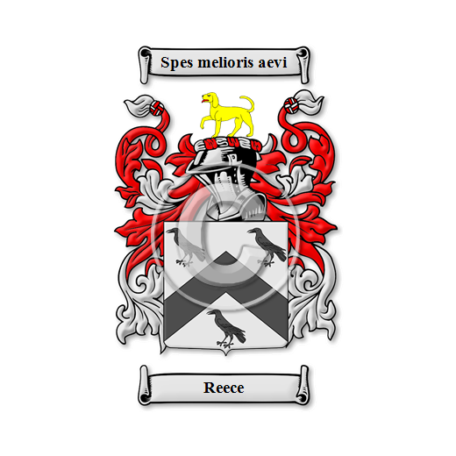

REECE/REESE AN ENDLESS LEGEND/HISTORY/HERITAGE OF FAMILIES